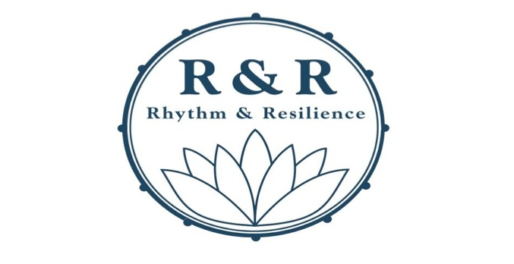
Drum Circle led by Robert Jospé with Tussi Kluge
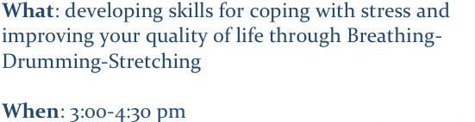
Every 2nd Sunday of the month- Nov. 11, 2012
Where: new location! Sunrise Community Center,
1412 Carlton Avenue, Suite 1, Charlottesville, VA 22902
434-960-7646

